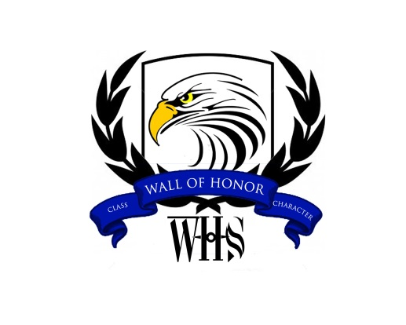
WALL OF HONOR, INC.
SPONSORSHIPS, TABLES, TICKETS, and ADVERTISING INFORMATION
Please respond by August 22, 2014
SPONSORSHIP LEVELS
____ PLATINUM SPONSOR: $2,000
____ GOLD SPONSOR: $1,000
____ SILVER SPONSOR: $500
____ BRONZE SPONSOR: $250
____ BLUE & SILVER SPONSOR: $100
____ SPONSORSHIP OF A CURRENT WHS STUDENT TO ATTEND THE BANQUET: $50/STUDENT
____ “JUST BECAUSE” SPONSOR: $50

ADVERTISING IN THE SOUVENIR BOOKLET (FULL PAGE AD = 8 ½” x 11”)
____Full page, inside front cover ad (color) - $750 (1 page available)
____Full page, inside back cover ad (color) - $750 (1 page available)
____Full page, inside second page ad (color) - $500 (1 page available)
____Full page, inside last page ad (color) - $500 (1 page available)
____Full page ad in B & W - $250
____Half page ad in B & W - $125
____ ¼ page ad in B & W - $75
____Business card ad in B & W - $25
____Patron’s List ad in B & W- $20

TICKETS AND TABLES
____ Number of tables (each table seats 10) - $500.00
____ Number of Individual tickets (each ticket is $50)
Please check your sponsorship level and/or ad size in the spaces provided above
Please put the number of tickets or the number of tables you are purchasing in the blanks

NO TICKETS WILL BE SOLD AT THE DOOR!!!!!!!!!!!!!!
NAME: _______________________________ Email Address: ______________________________
Mailing Address: ___________________________ City & State: ____________________________
Zip Code: ___________ AMOUNT ENCLOSED: ___________________________________________

PAYMENT OPTIONS:
- PayPal Available: www.whswallofhonor.com OR
- Mail this form along with ads and checks payable to:
Willowridge Wall of Honor, Inc.
A 501 ( c ) 3 Corporation
P O Box 1527, Missouri City, TX 77459

Questions: Contact Audrey Williams 281.437.7931

